Traveler
Upload the solution, without images!
Create a Web page (HTML5 + CSS3 + images) that looks and behaves like the screenshot below:
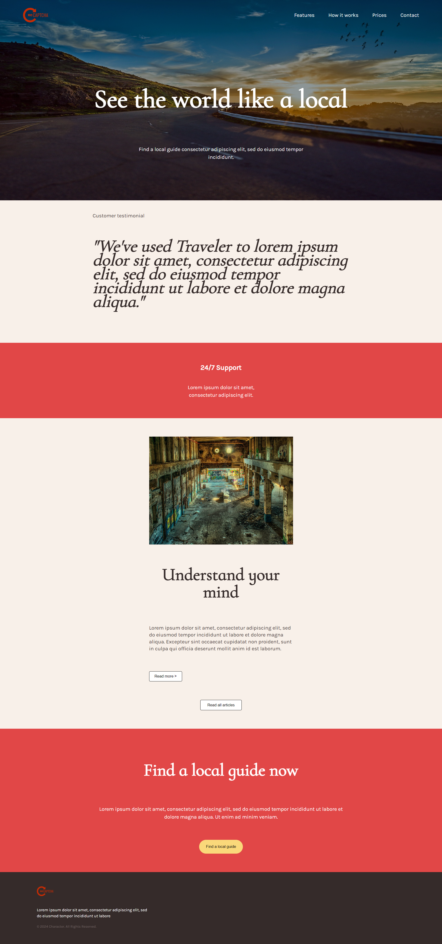
You are given the above screenshots + all required images.

Output
The output should be valid HTML5 + CSS3 + images that implement the above web page.

Constraints
- Use both fonts (Karla and Cormorant Infant). Examine the screenshot carefully and decide where to use each of the fonts.
  - https://fonts.googleapis.com/css2?family=Karla&display=swap
    - Font-size – 18px
  - https://fonts.googleapis.com/css2?family=Cormorant+Infant&display=swap
    - Font-size for big title – 90px
    - Font-size for other text – 16px
- The site should open correctly in the latest version of Chrome.

